Abdi Tadesse RU0010/16 Section-2

Part 1: RSA Implementation
Step 1: Generate RSA Keys
- Generate a private key:
openssl genpkey -algorithm RSA -out private_key.pem -pkeyopt rsa_keygen_bits:2048
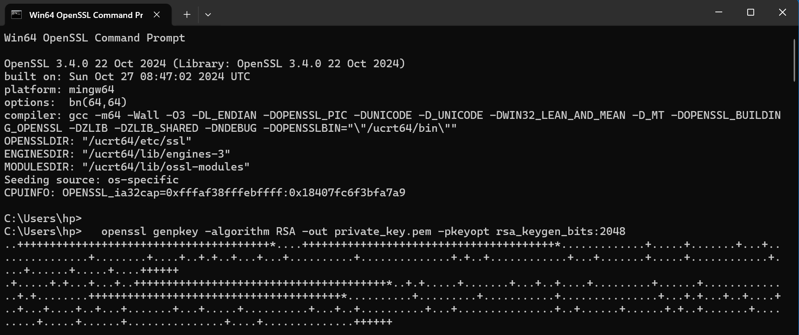
- Extract the public key:
openssl rsa -pubout -in private_key.pem -out public_key.pem
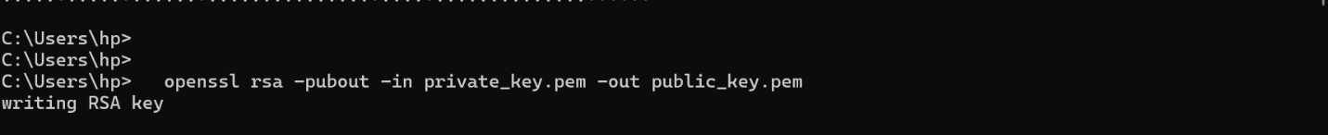

- Verify the keys:
openssl rsa -in private_key.pem -text -noout
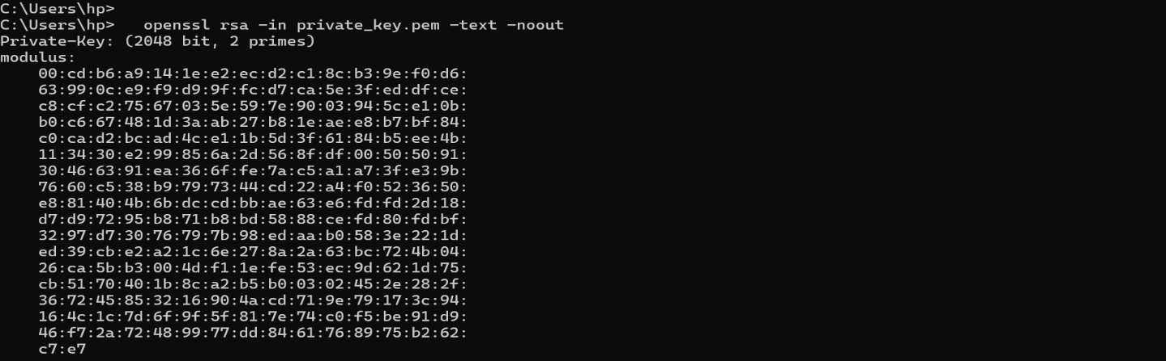
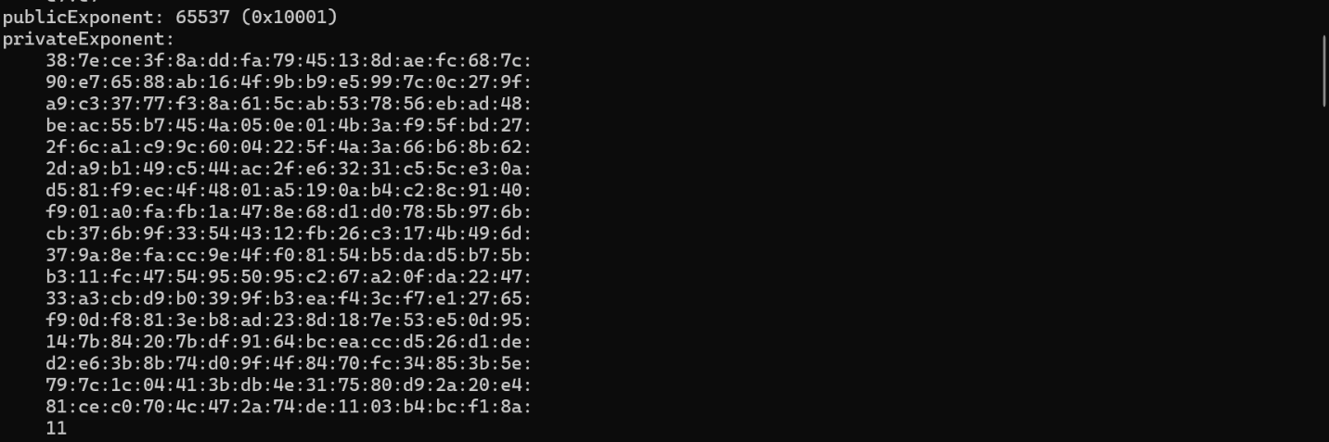
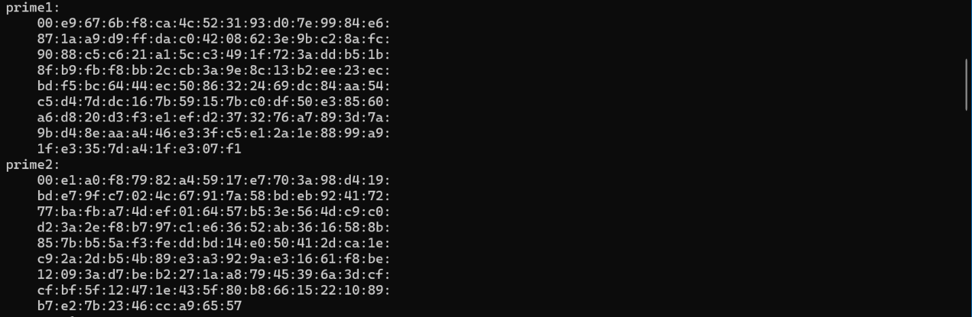
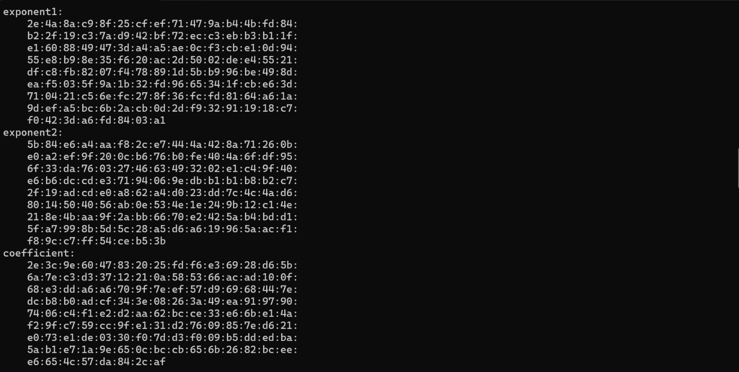

- openssl rsa -pubin -in public_key.pem -text -noout
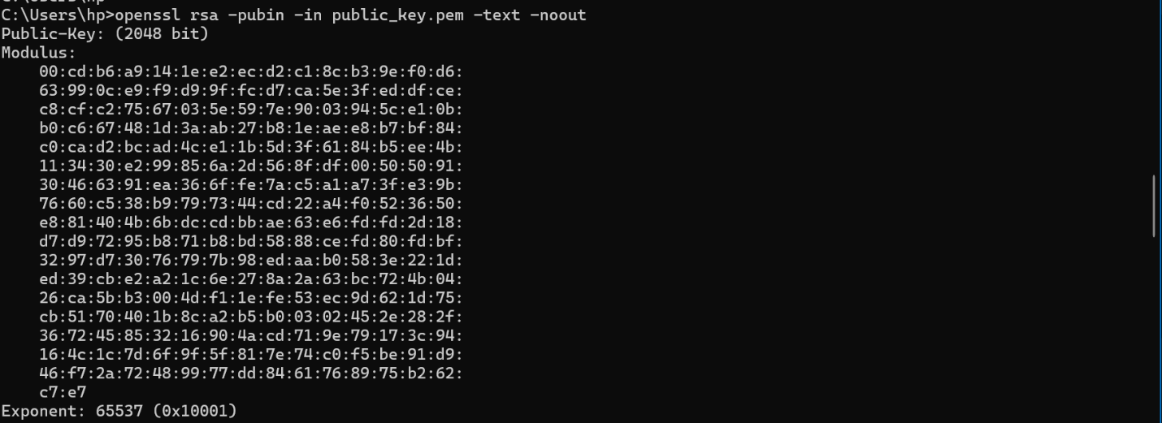
Step 2: Encrypt and Decrypt a Message
- Create a plaintext message file (e.g., message.txt).
echo " Write your name and ID here" > message.txt
- Encrypt the message using the public key:
openssl rsautl -encrypt -inkey public_key.pem -pubin -in message.txt -out encrypted_message.bin
- Decrypt the message using the private key:
openssl rsautl -decrypt -inkey private_key.pem -in encrypted_message.bin -out decrypted_message.txt
- Verify the decrypted message:
- cat decrypted_message.txt
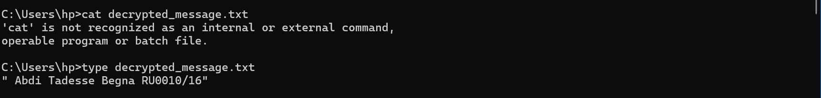

Part 2: AES Implementation
Step 1: Generate an AES Key
- Generate a 256-bit AES key:
openssl rand -base64 32 > aes_key.bin
Step 2: Encrypt and Decrypt a Message
- Encrypt a message file using AES:
openssl enc -aes-256-ecb -salt -in message.txt -out aes_encrypted_message.bin -pass file:./aes_key.bin
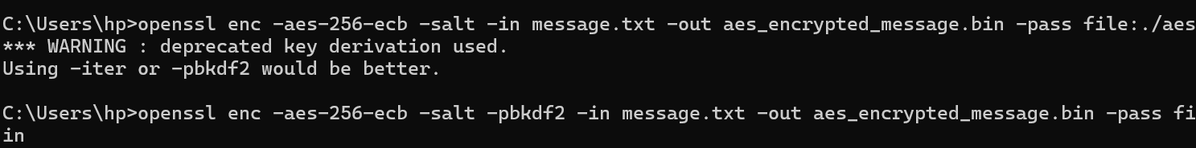
- Decrypt the AES-encrypted message:
openssl enc -d -aes-256-ecb -in aes_encrypted_message.bin -out aes_decrypted_message.txt -pass file:./aes_key.bin
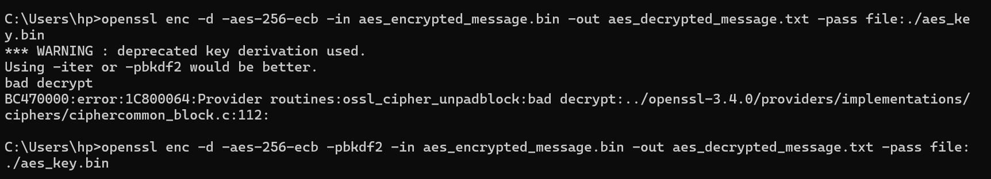
- Verify the decrypted message:
cat aes_decrypted_message.txt

Part 3: Hybrid Encryption Scheme
In this section, you will use RSA to securely exchange the AES key and IV, and then use AES to encrypt the message.
Step 1: Encrypt the AES Key with RSA
- Encrypt the AES key:
openssl rsautl -encrypt -inkey public_key.pem -pubin -in aes_key.bin -out encrypted_aes_key.bin
Step 2: Decrypt the AES Key and IV with RSA
- Decrypt the AES key:
openssl rsautl -decrypt -inkey private_key.pem -in encrypted_aes_key.bin -out decrypted_aes_key.bin
Step 3: Encrypt and Decrypt a Message Using the Hybrid Scheme
- Encrypt the message using the AES key:
openssl enc -aes-256-ecb -salt -in message.txt -out hybrid_encrypted_message.bin -pass file:./decrypted_aes_key.bin
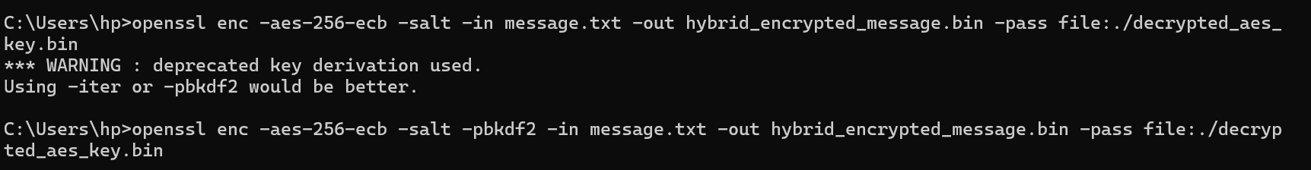
- Decrypt the hybrid-encrypted message:
openssl enc -d -aes-256-ecb -in hybrid_encrypted_message.bin -out hybrid_decrypted_message.txt -pass file:./decrypted_aes_key.bin
- Verify the decrypted message:
cat hybrid_decrypted_message.txt

Challenges & Solutions Summary
Deprecated Command Issue
- Problem: rsautl command not supported in OpenSSL 3.0+
- Solution: Replaced with pkeyutl command
Platform Compatibility
- Problem: Unix cat command failed in Windows
- Solution: Used Windows type command instead
Security Warning
- Problem: "deprecated key derivation" warning during AES encryption
- Solution: Added -pbkdf2 flag for secure key derivation
Decryption Failure
- Problem: "bad decrypt" error due to parameter mismatch
- Solution: Ensured consistent use of -pbkdf2 in both encryption and decryption

